**Sample Exam**

Course Databases Exam Time 120 minutes

Student ID Student Name

1. Please answer the following questions: (5+5+5+5+5=25)
2. Explain the components of DBMS core.

omission

1. Explain the recursio n in SQL Query.

omission

1. Explain the nature of the transaction.

omission

1. How does periodical dumping restore the database to a consistent state?

omission

1. Please explain E-R diagram and list the component of E-R diagram

omission

1. Hotel Management System

Introduction:

(1) One room have one or several beds, and each room has information of room ID (e.g., 201), price and bed number.

(2) Each customer has information of ID, name and gender.

(3) Each reserve record has information of the ID of customer, the ID of room and reserve time.

(4) Each room can be reserved by only one customer at the same time.

Table:

Room(RID, Price, Number);

Customer(CID, Name, Gender);

Reserve(RID, CID, Rdate)

Questions (6+6+6+6+6=30):

1. Find the id of room which has two beds.

SELECT RID

FROM Room

WHERE Number=1;

1. Find the name of customer who reserved Room 210.

SELECT Name

FROM Customer, Room

WHERE Customer.CID=Room.CID AND RID=’210’;

1. Find the room number which is reserved only once and print the name of customer who reserves this room.

SELECT C.Name, T.RID,

FROM Customer C, Reserve R, (

SELECT R1.RID, COUNT(*) AS num

FROM Reserve R1

GROUP BY R1.RID ) T

WHERE C.CID=R.CID AND R.RID=T.RID AND T.num=1;

1. Find the total times that each customer reserved rooms in 2018 and the corresponding customer name.

SELECT C.Name, T.times

FROM Customer C, (

SELECT CID, SUM(*) AS times

FROM Reserve

GROUP BY CID ) AS T

WHERE C.CID=T.CID;

(5) Find the name of customer who reserved all rooms.

SELECT Name

FROM Customer

WHERE NOT EXISTS(

SELECT * FROM Room

WHERE NOT EXISTS(

SELECT * FROM Reserve

WHERE Customer.CID=Reserve.CID AND Room.RID=Reserve.RID));

1. For the relationships in the second question, we have the following query:

SELECT Name

FROM Room, Customer, Reserve

WHERE Room.RID = Reserve.RID AND

Customer.CID = Reserve.CID AND

Room.Price > 500 AND

Customer.Gender = 'female' AND

Reserve.Rdate between [2019.10.01, 2019.10.07]

Please optimize the query and draw the query trees before and after optimization. (10)

$$σ_{1}:Room.Price > 500$$

$$σ_{2}:Customer.Gender='female'$$

$$σ_{3}:Reserve.Rdate between [2019.10.01, 2019.10.07]$$

Before:

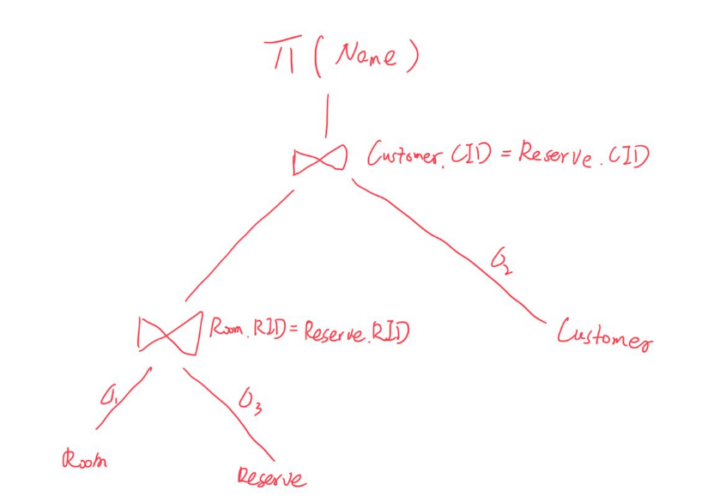

After:

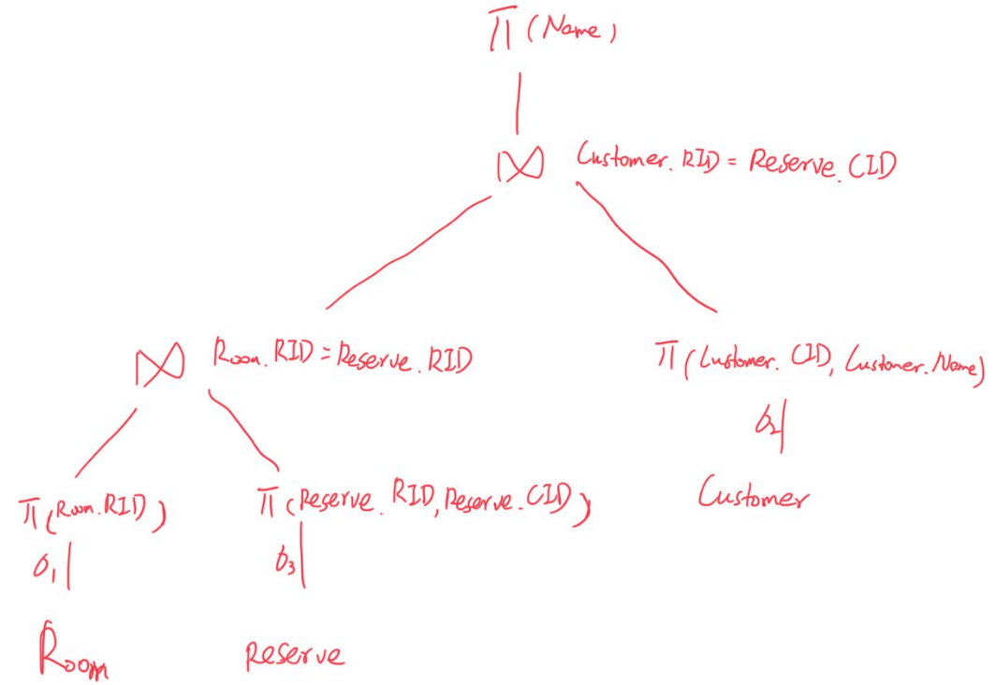

1. List three recovery strategies in DBMS and explain how they work. (9)

DB_ch4-3 P10-P15

$A.I→DB$ before commit,

after commit,

concurrently with commit TID →active list

1. The compatibility matrix of (S, X) locks is shown in Figure (a). Suppose that we change the compatibility matrix of (S, X) locks to the one as shown in Figure (b). Now we have *n* transactions {T1, T2..., Tn} that require concurrent access in a period of time. Assume that these *n* transactions are read operations. Will the system work properly? If yes, explain the reason; If not, what happens? (10)

|  |  |  |  |
| --- | --- | --- | --- |
|  | Locks already owned by other transactions | | |
| Lock request |  | **S** | **X** |
| **S** | Y | Y |
| **X** | N | N |

|  |  |  |  |
| --- | --- | --- | --- |
|  | Locks already owned by other transactions | | |
| Lock request |  | **S** | **X** |
| **S** | Y | N |
| **X** | N | N |

(a) Compatibility Matrix A (b) Compatibility Matrix B

The system will work properly.

Because all of these n transaction are read operations. The read operation only use the s locks. According to the figture(b), when s locks already owned by other transactions, s lock request is compatible. Therefore, n s locks can work at the same time.

1. Please list those sub-constraints included in Static constraints. Which sub-constrain contains Domain constrains? And explain what’s Domain constraints. For the Room table in Question 2, apply Assertion to ensure that the number of rooms >=0. (8)

Static constraints contain:

inherent constraints

implicit constraints

explicit constraints

implicit constraints contain Domain constraint.

Domain constraints: Field values must be of right type. Always enforced.

CREATE ASSERTION roomnumber

CHECK ((SELECT COUNT(*) FROM Room)>=0)

1. Please draw the E-R diagram of the reserve relationship. The entities include Sailors, Boats. The relationship between the entities are as follows: (8)
2. One Boats can be reserved by several sailors
3. One sailor can reserve several boats

Sailors

M

N

Boats

Reserve